America’s Freedom Festival
K-6 Supplementary Material

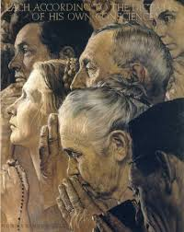
2019-2020 Theme
Freedom of Religion

Amendment 1 to the Constitution of the United States

Congress shall make no law respecting an establishment of religion, or prohibiting the free exercise thereof;

Content

I. Glossary of Terms
II. Recommended Lesson Material on Freedom of Religion
III. Examples from the Lives of the Founders regarding Religious Freedom
IV. Additional Perspectives

I. Glossary

Amendment: A change in or addition to a legal document.

Bill of Rights: The first ten amendments to the U.S. Constitution. The Bill of Rights lists many basic rights that the Federal Government may not interfere with and must protect. Nearly all these rights are now also protected from violations by state governments.

The Bill of Rights (first ten amendments) was ratified effective December 15, 1791.

Constitution: A plan of government that sets forth the structures and powers of government. In democracies, a constitution is an authorized law through which the sovereign people authorize a government to be established and grant it certain powers.

Freedom of Religion: The right to hold whatever religious beliefs one wishes and to practice religious beliefs without unfair or unreasonable interference from government.

Establishment Clause: The part of the First Amendment that prohibits the government from declaring an official religion.

Free Exercise Clause: The part of the First Amendment stating that Congress shall make no laws that prevent people from holding whatever religious beliefs they choose or that unfairly or unreasonably limit the right to practice religious beliefs.

II. Recommended Lesson Material on Freedom of Religion

1. The Center for Civic Education (www.civiced.org) has produced three volumes entitled We the People: The Citizens and the Constitution. Each volume is geared for students of different grade levels and has a specific lesson focused on the freedom of religion as stated in the 1st Amendment of the U. S. Constitution. Each lesson includes purpose, terms to know, relevant content, ideas to discuss and activities to do. Lessons on freedom of religion are entitled, “How Does the Constitution Protect Freedom of Religion?”

Level 1: Lesson 18, pp. 145-152.
Level 2: Lesson 24, pp. 195-202.
Level 3: Lesson 28, pp. 203-210.

2. The National Constitution Center (constitutioncenter.org) offers an online resource called The Interactive Constitution. Select Amendment 1-The United States Constitution and from the submenu, Freedom of Religion, Speech, Press, Assembly, and Petition. You will then be able to select clauses of the 1st Amendment and there are two related to freedom of religion, Establishment Clause and Free Exercise Clause. After the presentation of general information there is a Matter of Debate in which two different point of view are provided on each topic.

3. (TeachingAmericanHistory.org) offers access to original documents related to the topic Religious Liberty & the American Character. Some of the accessible documents include:

- James Madison’s Memorial & Remonstrance against Religious Assessments (June 20, 1785)
- Thomas Jefferson’s Virginia Statute for Religious Freedom (January 16, 1786)
- James Madison’s Speech on Amendments to the Constitution (June 8, 1789)
- George Washington’s Letter to the Hebrew Congregation at Newport (August 18, 1790)
- Adoption of the Bill of Rights (December 15, 1791)
- James Madison’s Essay on Property (March 29, 1792)

4. The Freedom Forum Institute (freedomforuminstitute.org) sponsors the First Amendment Center which provides ample resources to help citizens learn about freedom of religion. Under that topic are resources related to an overview and history, understanding the clauses in the 1st Amendment, examples and challenges to this freedom.

5. The Religious Freedom Center offers blended learning courses to prepare teachers and parents to be knowledgeable about issues of religion and public schools. Resources are available at ReligiousFreedomCenter.org.

6. The United States Courts (uscourts.gov) offers material related to religious freedom and the courts. Introductory information is as follows:

First Amendment and Religion
The First Amendment has two provisions concerning religion: the Establishment Clause and the Free Exercise Clause. The Establishment clause prohibits the government from "establishing" a religion. The precise definition of "establishment" is unclear. Historically, it meant prohibiting state-sponsored churches, such as the Church of England.
Today, what constitutes an "establishment of religion" is often governed under the three-part test set forth by the U.S. Supreme Court in Lemon v. Kurtzman, 403 U.S. 602 (1971). Under the "Lemon" test, government can assist religion only if (1) the primary purpose of the assistance is secular, (2) the assistance must neither promote nor inhibit religion, and (3) there is no excessive entanglement between church and state.
The Free Exercise Clause protects citizens' right to practice their religion as they please, so long as the practice does not run afoul of a "public morals" or a "compelling" governmental interest. For instance, in Prince v. Massachusetts, 321 U.S. 158 (1944), the Supreme Court held that a state could force the inoculation of children whose parents would not allow such action for religious reasons. The Court held that the state had an overriding interest in protecting public health and safety.
Sometimes the Establishment Clause and the Free Exercise Clause come into conflict. The federal courts help to resolve such conflicts, with the Supreme Court being the ultimate arbiter.
Check out similar cases related to Engel v. Vitale that deal with religion in schools and the Establishment Clause of the First Amendment.
7. There is unit on religious freedom and democracy (facinghistory.org) based on an historic example involving President George Washington. The introduction to the material states:
George Washington’s 1790 Letter to the Hebrew Congregation of Newport, Rhode Island is a landmark in the history of religious freedom in America and part of a founding moment in US history when the country was negotiating how a democracy accommodates differences among its people.
In the United States and globally, recent debates about group identity and immigration overlap with those about faith and citizenship. Today, Buddhists, Christians, Muslims, Hindus, and Jews, as well as people who belong to no religion, often find themselves living alongside neighbors whose beliefs and practices are quite different from their own. With this new diversity, there is a growing need worldwide to discuss what is necessary for people to live together, including the opportunities and limits of religious freedom in a democracy. These are not easy conversations, and the tone of recent debates about the differences between people suggests that we need to get better at talking about these issues or else risk further polarization.
The classroom resources that follow are designed to help teachers both introduce Washington’s letter into the classroom in historical context and begin to explore with their students the echoes of this powerful statement in the more than two centuries of history since it was written.

III. Examples from the Lives of the Founders regarding Religious Freedom

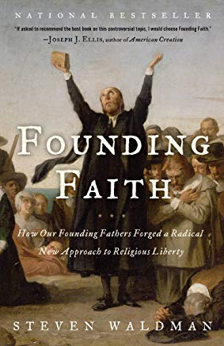
The following material includes excerpts from Steven Waldman (2008), Founding Faith: How Our Founding Fathers Forged a Radical New Approach to Religious Liberty, New York: Random House.

Waldman’s Introduction:

Freedom of conscience, as the Founders like to call it, is one of the most important characteristics of American democracy.

Why do we have religious freedom? How did it happen? And therefore, how do we preserve and treasure it?

Most colonies were established to promote particular religious denominations. America was settled primarily by people who wanted rule of one religious denomination over others.

Four of the key figures in defining religious freedom during the Revolutionary period then served as president of the United States. And what did they conclude? That they disagreed with one another. Each contributed different insights. However, the Founding Fathers did share several common traits: Each felt religion was extremely important, at a minimum to encourage moral behavior and make the land safe for republican government; each took faith seriously enough to conscientiously seek out a personal path that worked for him; each rejected major aspects of his childhood religion; and none accepted the full bundle of creeds offered by his denomination. In other words, they were spiritual enough to care passionately about religious freedom, but not so dogmatic that they felt duty-bound to promote a particular faith. This combination led them to promote religious freedom rather than religion.

The birth of religious freedom was not inevitable. Through a variety of battles—some local, some national, some born of enlightenment and some of parochialism—these men and women helped create a radical new three-part creed:
- Religion is essential to the flourishing of a republic
- To thrive, religion needs less help, not more, from the state
- God gave all humans the right to full religious freedom

The Founding Faith, then, was not Christianity, and it was not secularism. It was religious liberty—a revolutionary formula for promoting faith by leaving it alone.

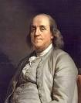
Benjamin Franklin

(pp. 24-26)

Pennsylvania had been established by William Penn, a Quaker, as a “Holy Experiment” in religious tolerance. But contrary to popular impressions, the colony was not secular; the “Quaker Party” controlled the legislature. Pennsylvania therefore tested an interesting hypothesis: Could one merge church and state if those in power were religious pluralist rather than exclusivists, as they had been in Massachusetts and Virginia?

On many of the issues that tripped up other colonies, the Quakers did well. They did not force people of other faiths to pay taxes to support Quaker meetinghouses. Ministers could criticize politicians without being thrown in jail. Philadelphia had the only Catholic church in all the colonies protected by authorities, and diversity flourished. As one traveler wrote in 1750, “Sects of every belief are tolerated. You meet here Lutherans, Reformed, Catholics, Quakers, Mennonites, Herrenhuter or Moravian Brethren, Seventh Day Baptists, Dunkers, Presbyterians, the New Born, Free Masons, Separatists, Free Thinkers, Negroes and Indians.” Franklin admired the Quakers for their tolerance and lack of clergy. Compared with other colonies, Pennsylvania managed its diversity well—and the other Founding Fathers repeatedly pointed to Pennsylvania’s thriving economic and cultural life as evidence that religious toleration was smart as well as right.

Pennsylvania advocated a stricter separation of church and state than would the US Constitution. It prohibited state support of particular faiths and it guaranteed citizenship rights only to a person “who acknowledges the being of a God.” Franklin wanted men of any faith to be able to serve in the legislature. He compromised to get the constitution through.

Though the Pennsylvania experiment failed for different reasons than those of Massachusetts, Maryland, or Virginia, Franklin could not help but observe that any government dominated by a particular religious faction—even one committed to tolerance—would struggle if it tried to legislate religious views.

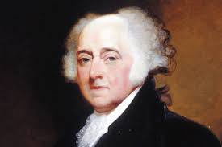
John Adams

(pp. 37-38)

As the colonies became estranged from Great Britain, Adams focused on another facet of faith: the important role it must play if America were to become an independent republic. Under monarchy, wickedness can be controlled by force. But in a democracy, the goodness of ordinary people becomes essential. “The best republics will be virtuous,” he wrote in his Defence of the Constitutions of Government of the United States. And without religion, virtue could not flourish—because, while Adams didn’t believe in original sin, he surely did believe in sin. “When men are given up to the rule of their passions, they murder like weasels for the pleasure of murdering, like bulldogs and bloodhounds in a fold of sheep,” he wrote. Religion was the only thing that could tame our savage natures. “I look upon Religion as the most perfect System,” he wrote Abigail.

Religion makes good citizens. “No other institution for education, no kind of political discipline could diffuse this kind of necessary information, so universally among the rank and descriptions of citizens.”

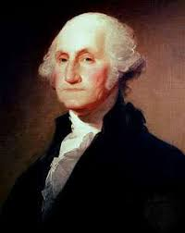
George Washington

(pp. 57-61)

Washington, like Franklin and the other Founding Fathers, considered religion essential to the creation of a democracy. In his Farewell Address, he said that the most important safeguards were religion, morality, and virtue. “Of all the dispositions and habits which lead to political prosperity, religion, and morality are indispensable supports. Reason and experience both forbid us to expect that national morality can prevail in exclusion of religious principle.”

Washington’s most significant contribution was his commitment to religious tolerance. At one point, Washington surveyed all the possible causes of America’s greatness and highlighted just two. The first was the “cheapness of land,” which allowed for much of the population to become property owners. The second was “civil and religious” liberty, which “stand perhaps unrivalled by any civilized nation on earth.”

The inherent pluralism of the Continental army helped spread tolerance throughout the colonies. The Continental army consisted of Baptist Rhode Islanders, Dutch Reformed New Yorkers, New Jersey Presbyterians, Connecticut Congregationalists, and even Maryland Catholics. As veterans, the men who witnessed this behavior would later constitute the leadership of the nation.

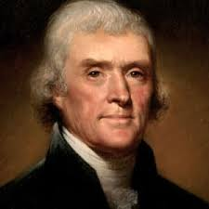
Thomas Jefferson

(pp. 73-75)

In terms of the history of religious freedom, the most important words in the Declaration are endowed by their Creator, for they imply a powerful idea about the nature of freedom. After all, God is not the only possible source of rights. Jefferson genuinely believed that rights came from above. The “God Who gave us life,” he wrote, “gave us liberty at the same time.” “The rights of conscience we never submitted, we could not submit. We are answerable for them to our God.” This idea—that freedom comes from God—was the foundation for a new American conception of rights. If rights resulted from a social compact—a practical way of allowing for mutual survival—then they certainly could be altered by the majority when it seemed practical or convenient. If they came from God, however, they were immutable and inviolate, whether you were in the majority or not. Toleration assumes that the state was generously choosing to do the toleration. As Thomas Paine put it later, “Toleration is not the opposite of intolerance but the counterfeit of it. Both are despotisms: the one assumes to itself the right of withholding liberty of conscience, the other of granting it.” A God-given right is something quite different.

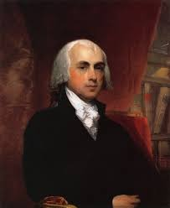

James Madison

(pp. 99-126)

Madison in some ways had the perfect combination of personal characteristics to be the champion of religious liberty. Because he deeply respected religious people and religion—studying it avidly—he wanted to preserve its expression and health. But because he wasn’t intensely attached to a particular approach, he could embrace pluralism and the marketplace of spiritual ideas. And, perhaps most important, he was humble.

“Conscience is the most sacred of all property; other property depending in part on positive law, the exercise of that being a natural and unalienable right.”

The rights of conscience and freedom of press were the “choicest flowers,” he stated, and should, along with trial by jury, be placed “out of the power of the Legislature to infringe them.”

Madison felt what was far more likely to protect religious freedom than “parchment barriers” was religious diversity: the proliferation of a “multiplicity of sects, which pervades America, and which is the best and only security for religious liberty in any society. For where there is such a variety of sects, there cannot be a majority of any one sect to oppress and persecute the rest.”

IV. Additional Perspectives

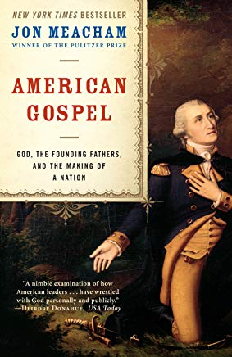
Meacham, J. (2006), American Gospel: God, the Founding Fathers, and the Making of a Nation. NY: Random House.

The great good news about America—the American gospel, if you will—is that religion shapes the life of the nation without strangling it. Belief in God is central to the country’s experience, yet for the broad center, faith is a matter of choice, not coercion, and the legacy of the Founding is that the sensible center holds. It does so because the Founders believed themselves at work in the service of both God and man, not just one or the other. Driven by a sense of providence and an acute appreciation of the fallibility of humankind, they created a nation in which religion should not be singled out for special help or particular harm. The balance between the promise of the Declaration of Independence, with its evocation of divine origins and destiny, and the practicalities of the Constitution, with its checks on extremism, remain perhaps the most brilliant American success (p.5).

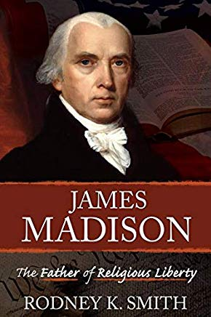
Rodney K. Smith (2019). James Madison: The Father of Religious Liberty. Springville, UT: Cedar Fort.

(p. 312)

Understanding the right of conscience, in Madisonian terms, as the most sacred of property is, indeed, illuminating. Every citizen enjoys an equal right of conscience. The way individuals exercise their respective rights of religious conscience may differ, but everyone individual’s chosen form of exercise is protected. That is what equality means in this context. To take the right to exercise one’s conscience, in any instance, is to rip the heart and soul out of a person who feels bound by her or his conscience to obey God. Only a tyrant of the worst sort would deprive another of what is the most precious and sacred to the individual, his or her very soul. Each American share, whether they acknowledge it or not, equally in the right of conscience this most sacred of all property, regardless of gender, ethnicity, sexual orientation, or religion. Furthermore, to depreciate this most sacred of all property (right) weakens all other rights, particularly the rights contained in the First Amendment.

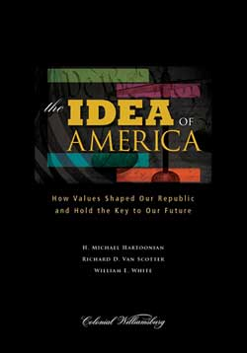
Hartoonian, H. M., Can Scotter, R. D. & White, W. E. (2013). The Idea of America: How values shaped our republic and hold the key to our future. The Colonial Williamsburg Foundation.

(pp. 82-92)

Our freedom of religion expression is quite probably the most remarkable aspect of American history and culture. The First Amendment reads: “Congress shall make no law respecting an establishment of religion, or prohibiting the free exercise thereof.” Very few American understand how distinctive this simple statement makes them. Like ethnicity and language, religion has always been one of the principle way to distinguish among groups, and perhaps more importantly, to define enemies.

Deeply held religious beliefs have led to proselytizing, which challenges the beliefs of others and almost inevitably leads to conflict—except in the United States of America. The United States has been remarkably free of the religious friction, strife, and war that has affected much of human history and is still common in many parts of the world. This is a tribute to the nation’s remarkable Constitution, in particular the wisdom and influence of the First Amendment.

Clearly, religion plays an important role in American life. In a real sense, the hallmark of a citizen is to understand that reason and faith both are important ways of thinking about the world. More importantly, however, is the ability to discriminate between faith and reason, hold both in the mind and heart simultaneously, and know when to use one or the other.

